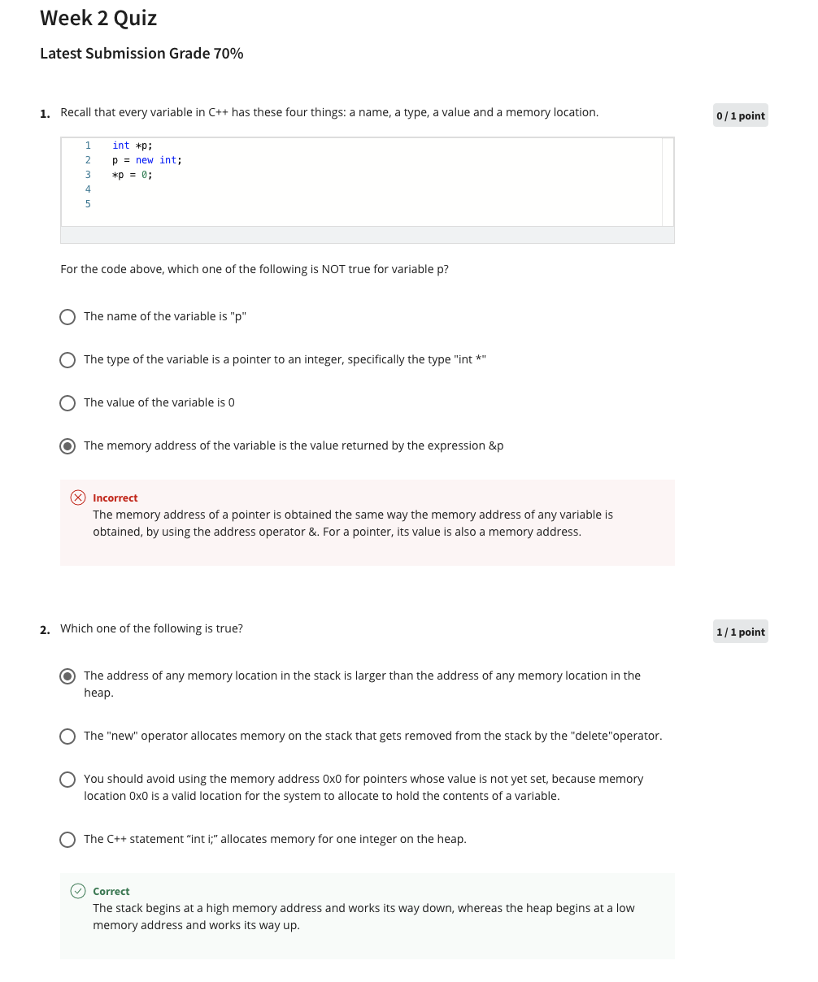

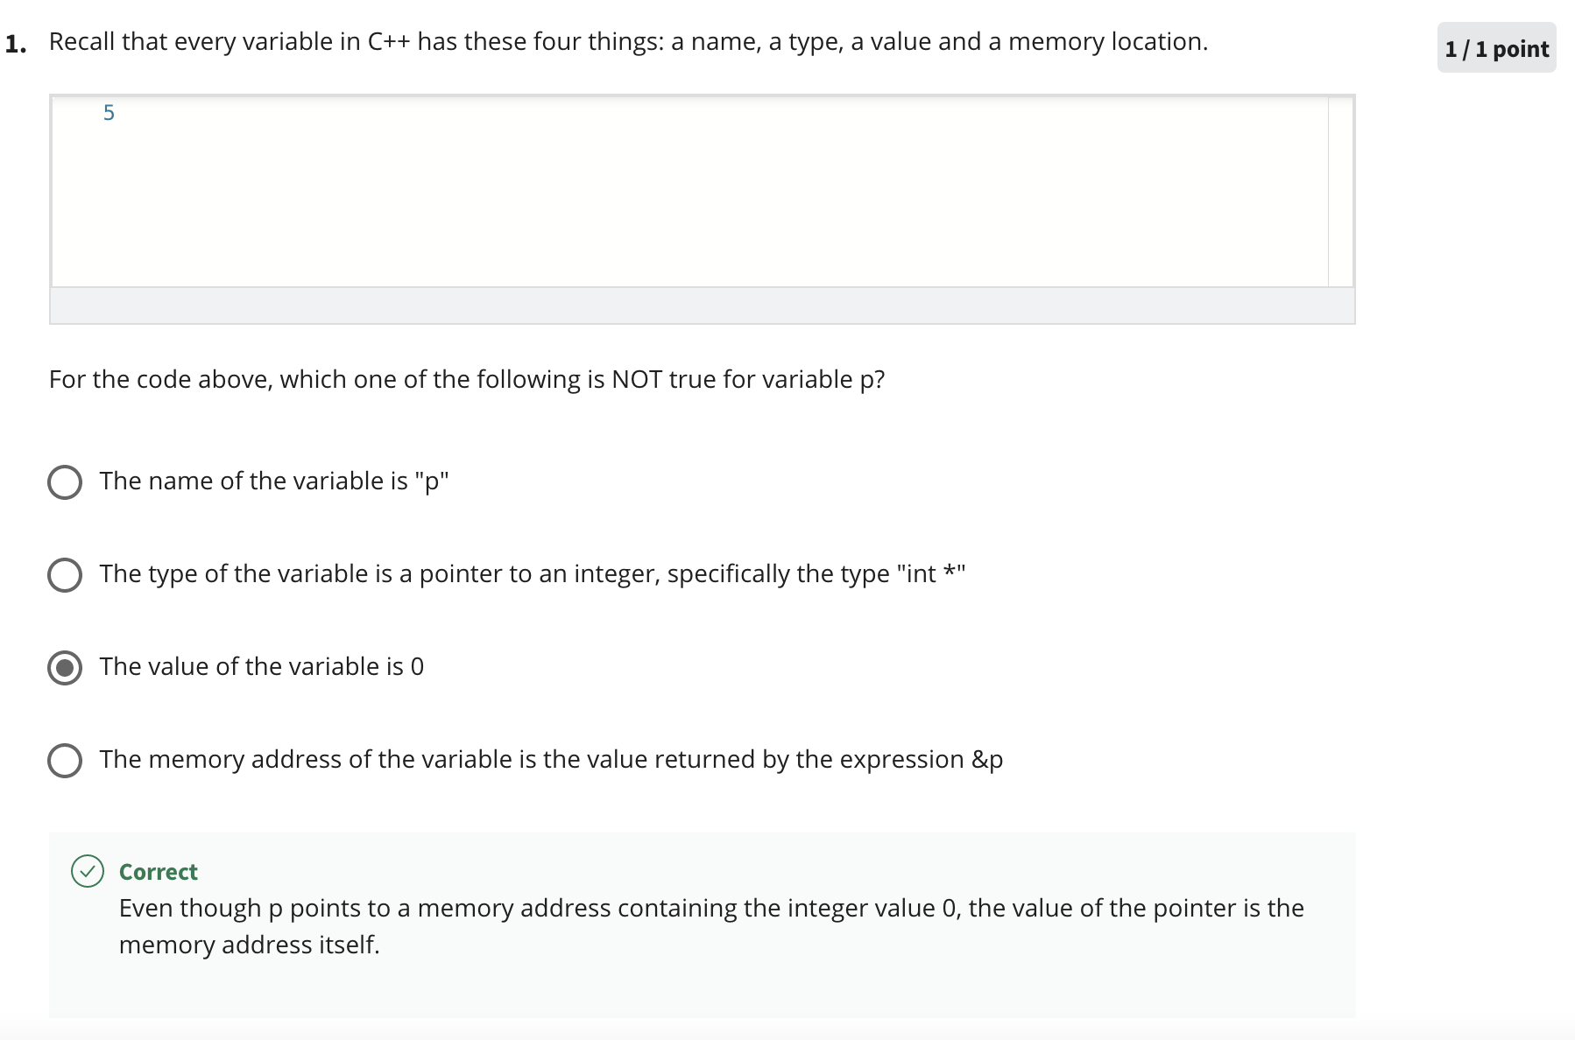

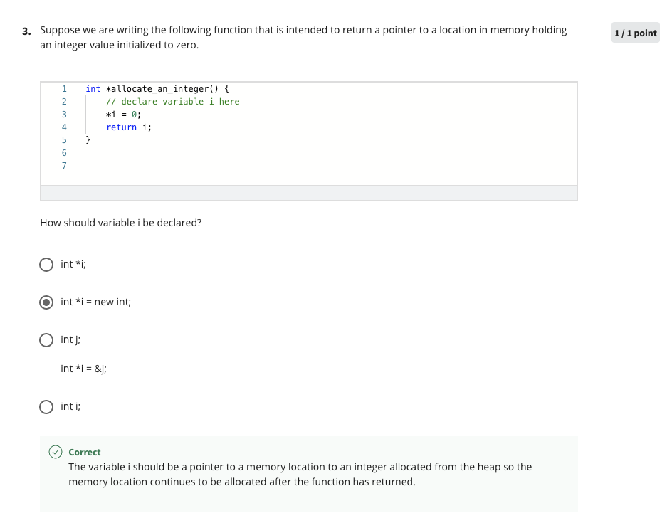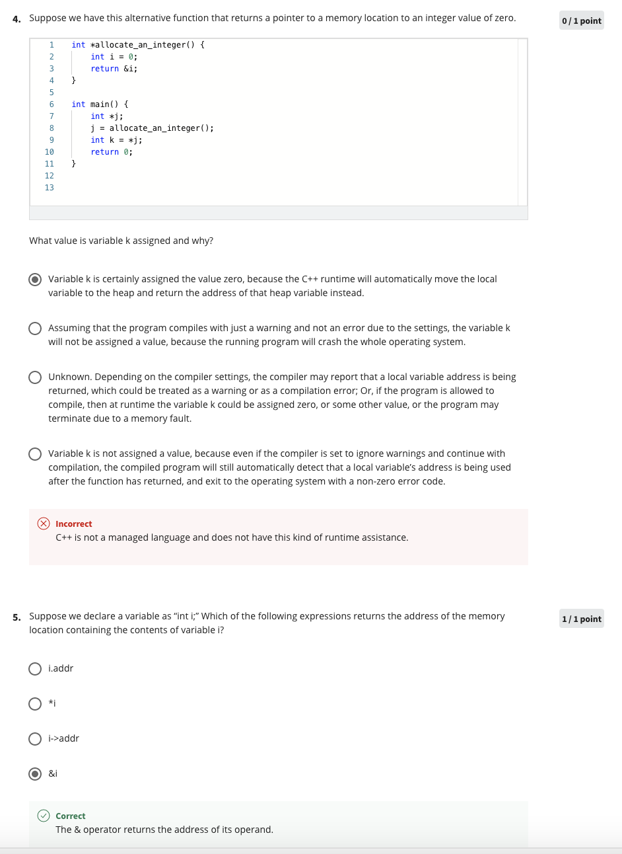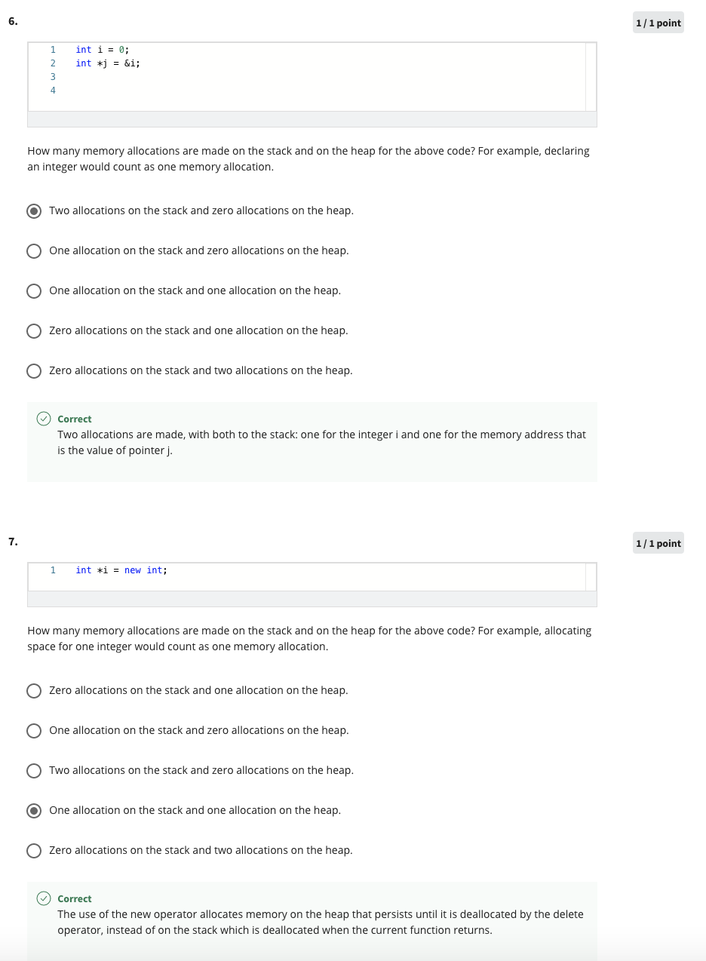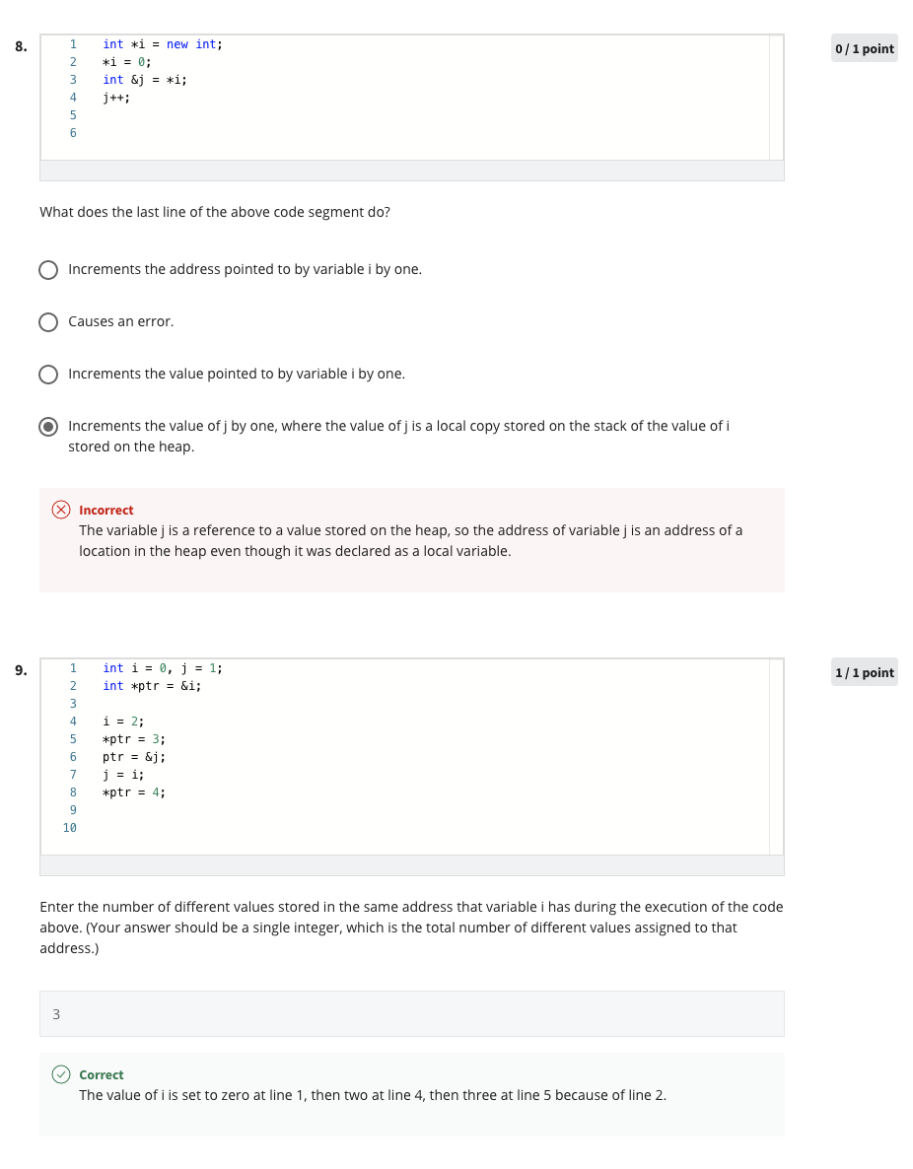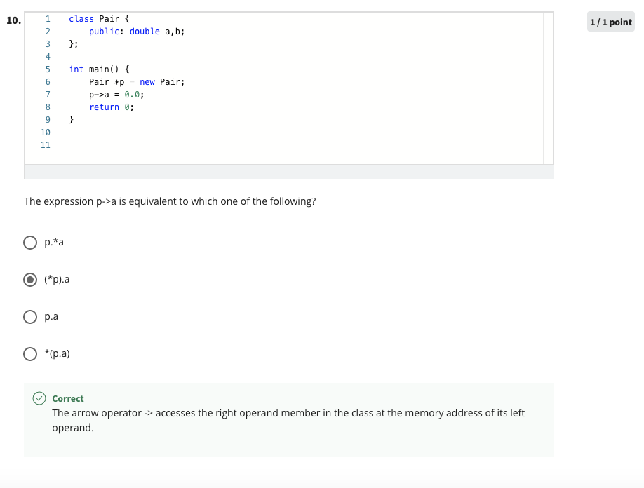

#include <iostream>

// This class Pair has already been defined for you.

// (You may not change this definition.)

class Pair {

public:

int first, second;

void check() {

first = 5;

std::cout << "Congratulations! The check() method of the Pair class \n has executed. (But, this isn't enough to guarantee \n that your code is correct.)" << std::endl;

}

};

// Insert your declaration and implementation of the function pairFactory()

// below, by replacing "..." with proper C++ code. Be sure to declare the

// function type to return a pointer to a Pair.

Pair \*pairFactory() {

// ...

// (You can use as many lines as you want.)

return new Pair;

}

// Your function should be able to satisfy the tests below. You should try

// some other things to convince yourself. If you have a bug in this problem,

// the usual symptom is that after you submit, the grader will crash with a

// system error. :-)

int main() {

Pair \*p;

p = pairFactory();

// This function call should work without crashing:

p->check();

// Deallocating the heap memory. (Assuming it was made on the heap!)

delete p;

std::cout << "If you can see this text, the system hasn't crashed yet!" << std::endl;

return 0;

}